Lab Check 2

Modul 6

Qornain Aji

21/481767/TK/53170

Kode 1:

Program memiliki fungsi untuk membalikkan urutan dari myarray dari elemen terkecil hingga terbesar. Kami juga melakukan modifikasi agar user bisa secara interaktif memberikan masukan sesuai keinginan.

#*include*<iostream>

using namespace std;

int main ()

{

 int myarray[5];

 cout<<"Input 5 element numbers : \n";

*for* (int i=0;i<5;i++)

 {

     cout<<i+1<<": ";

     cin>>myarray[i];

     cout<<"\n";

 }

 cout<<"\nInput list is \n";

*for*(int i=0;i<5;i++)

 {

 cout <<myarray[i]<<"\t";

 }

*for*(int k=1; k<5; k++)

 {

 int temp = myarray[k];

 int j= k-1;

*while*(j>=0 && temp <= myarray[j])

 {

 myarray[j+1] = myarray[j];

 j = j-1;

 }

 myarray[j+1] = temp;

 }

cout<<"\nOutput list is \n";

*for*(int i=0;i<5;i++)

 {

 cout <<myarray[i]<<"\t";

 }

*return* 0;//*Lupa return 0;*

}

Output1:

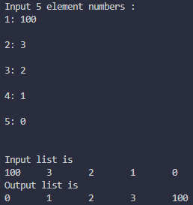

Kode2:

Kode setelah ditambahkan luaran untuk nama yang tertua.

#*include*<iostream>

using namespace std;

struct

{

 int roll,age;

 string name;

}vr[4];

int main()

{

 int i,j,k, max;

 string nameprint;//*string untuk menyimpan data nama tertua*

*for*(i=0; i<4; i++)

 {

 cout<<"Enter "<<i+1<<" Student Record\n";

 cout<<"Enter Roll no: "<<endl;

 cin>>vr[i].roll;

 cout<<"Enter age : "<<endl;

 cin>>vr[i].age;

 cout<<"Enter Name : "<<endl;

 cin>>vr[i].name;

 }

 cout<<endl;

*for*(j=0; j<4; j++)

{

 cout<<"\nDisplay "<<j+1<<" Student Record";

 cout<<"\nRoll no.: "<<vr[j].roll;

 cout<<"\nAge : "<<vr[j].age;

 cout<<"\nName : "<<vr[j].name<<endl;

 }

 max = vr[0].age;

*for* (k = 1; k < 4; k++)

 {

*if* (max<vr[k].age)

 max=vr[k].age;

 nameprint=vr[k].name;// *index ke k untuk nama tertua*

 }

cout << "\nThe oldest age's student is : " <<max;

cout << "\nThe oldest student names : " <<nameprint;

*return* 0;

}

Output:

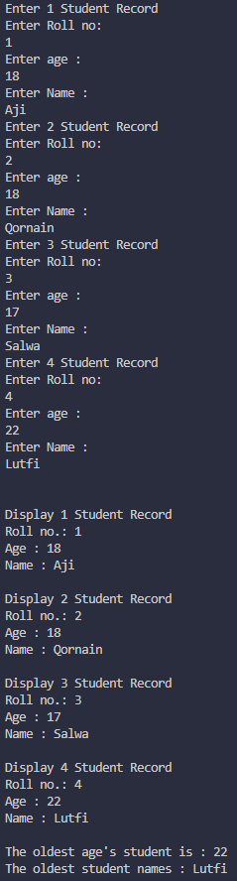

Kode3:

#*include*<iostream>

using namespace std;

// *declare functions*

double add(double num1, double num2, double num3);

double avg(double sum, int n);

// *main function*

int main()

{

// *declare variables*

 double num[3];//*Masukan berupa array double*

 double sum, average;

// *take input from end-user*

 cout << "Enter three Numbers :: ";

 cin >> num[0] >> num[1] >> num[2];

// *calculate sum value*

 sum = add(num[0], num[1], num[2]);

// *calculate average value*

 average = avg(sum, 3);

// *display result*

 cout << "Sum = " << sum << endl;

 cout << "Average = " << average << endl;

*return* 0;

}

// *function to add three numbers*

double add(double num1, double num2, double num3)

{

*return* num1+num2+num3;

}

// *function to calculate average of n number*

double avg(double sum, int n)

{

*return* sum / n;

}

Saya mengganti num1, 2, 3 pada int main degnan num[3] sehingga berubah menjadi array.

Output3:

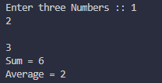

Kode5:

#*include*<iostream>

using namespace std;

int main()

{

    char matrix[3] [3] = {'x','x','x','x','x','x','x','x','x'};

    int i, j;

//*for diagonal matrix function*

    cout<<"\n---Diagonalize Matrix X---"<<endl;

*for*(i=0;i<3;i++)

    {

*for*(j=0;j<3;j++)

        {

*if*(i==j)

            {

                cout<<matrix[i][j];

            }*else*

            {

                cout<<"\t";

            }

        }

        cout<<"\n";

    }

    cout<<"\n---Trianglize Matrix X---"<<endl;

*for*(i=0;i<3;i++)

    {

*for*(j=0;j<=i;j++)

        {

            cout<<matrix[i][j];

            cout<<"\t";

        }

        cout<<"\n";

    }

*return* 0;

}

Output5:

